**Name :** V Venkata Sri Prasad

**Batch:** Data Engineering

**Date:** 24/04/2023 – Day 6

Topics

1. What Is the PARTITION BY Clause in SQL?
2. Schemas
3. How to calculate Subtotals in SQL Queries
4. Regex
5. Views
6. Rules and Restrictions to Group and Filter Data in SQL queries

**What Is the PARTITION BY Clause in SQL?**

The SQL PARTITION BY expression is a subclause of the OVER clause, which is used in almost all invocations of window functions like AVG(), MAX(), and RANK(). As many readers probably know, window functions operate on window frames which are sets of rows that can be different for each record in the query result. This is where the SQL PARTITION BY subclause comes in: it is used to define which records to make part of the window frame associated with each record of the result.

The first thing to focus on is the syntax. Here’s how to use the SQL PARTITION BY clause:

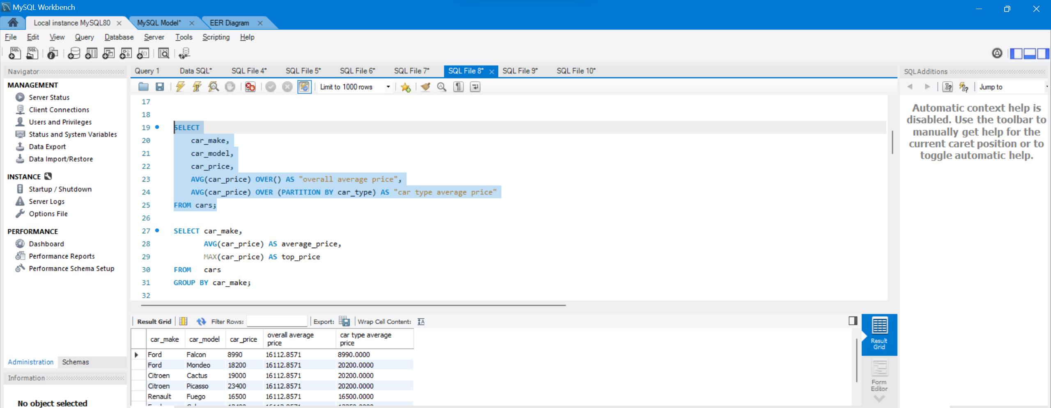

**Going Deep With the SQL PARTITION BY Clause**

The GROUP BY clause groups a set of records based on criteria. This allows us to apply a function (for example, AVG() or MAX()) to groups of records to yield one result per group.

As an example, say we want to obtain the average price and the top price for each make. Use the following query:

|  |
| --- |
| SELECT car_make,         AVG(car_price) AS average_price,         MAX(car_price) AS top_price  FROM   car_list_prices  GROUP BY car_make |

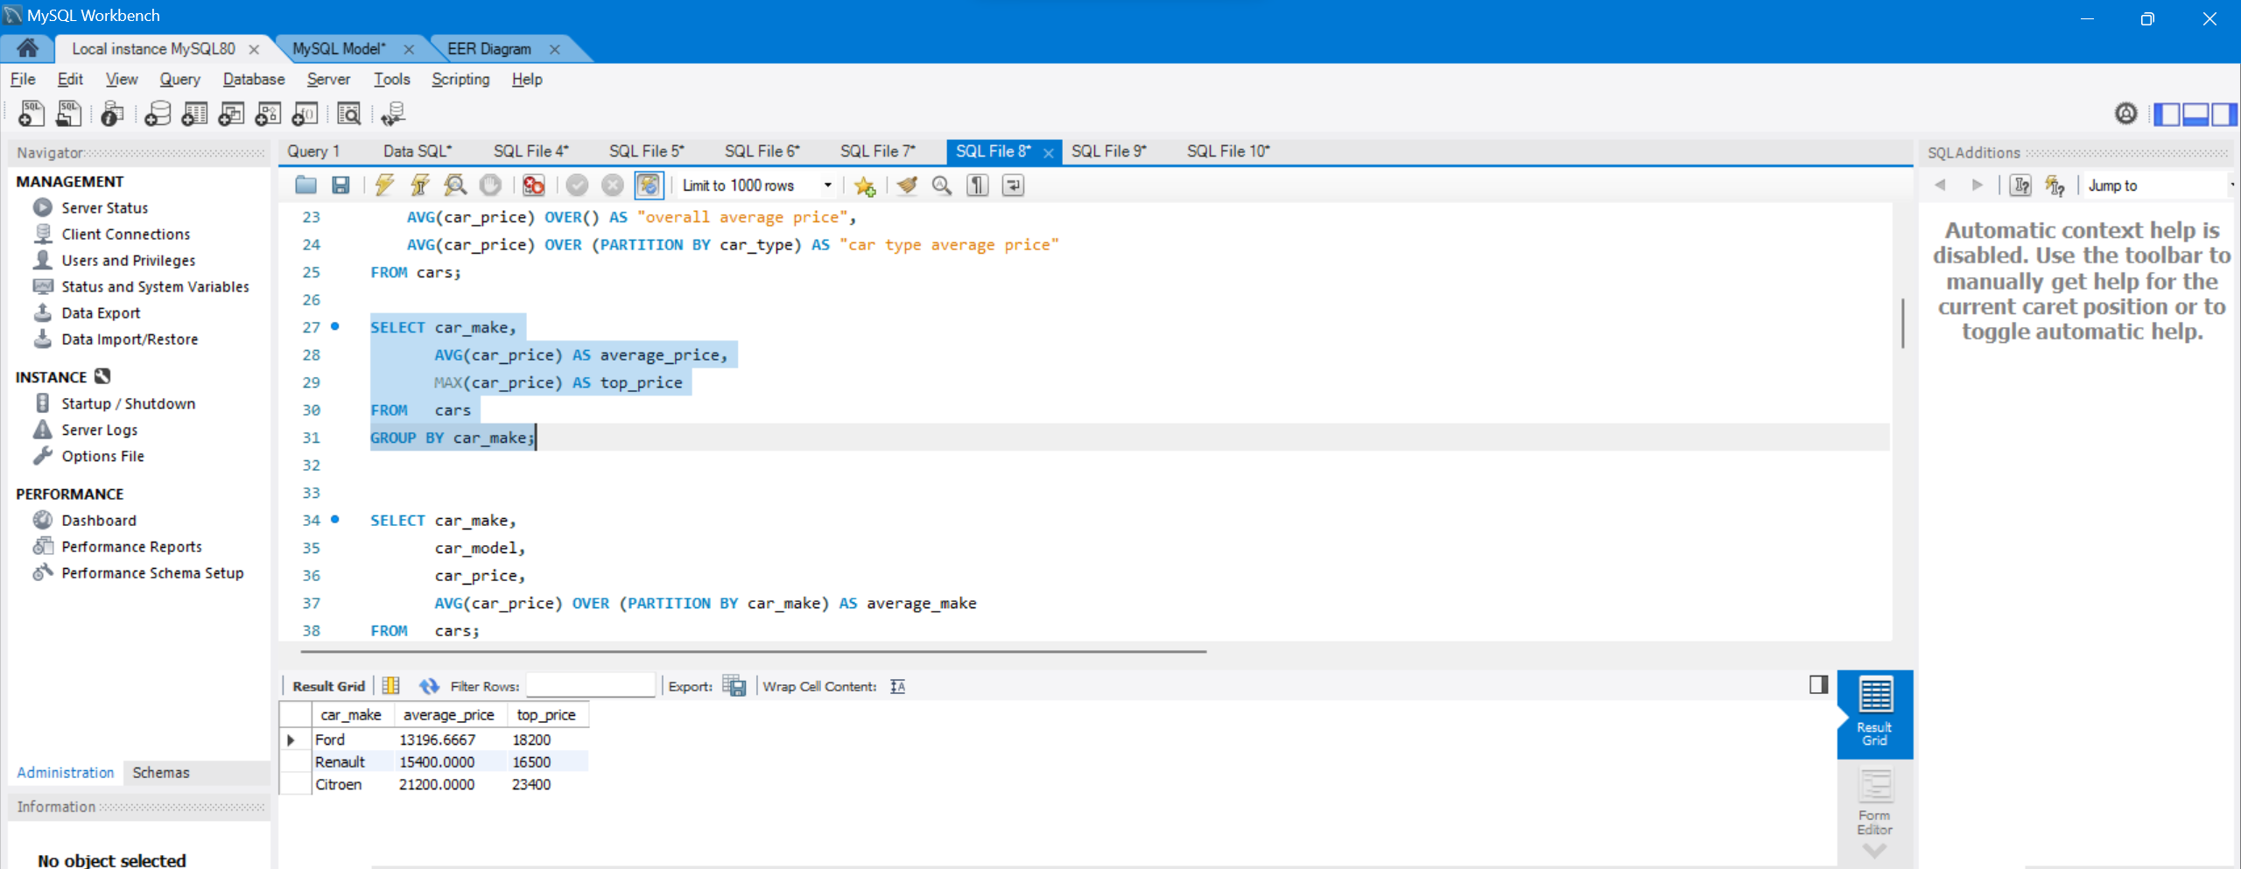

|  |
| --- |
| SELECT car_make,         car_model,         car_price,         AVG(car_price) OVER (PARTITION BY car_make) AS average_make  FROM   car_list_prices |

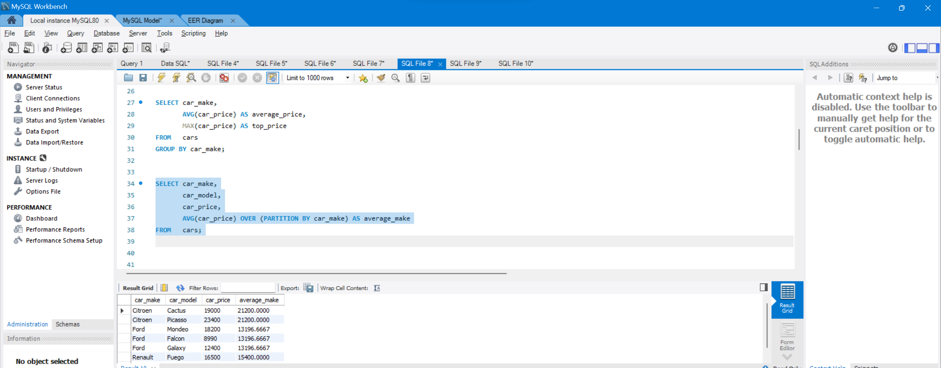

**The SQL PARTITION BY Clause in Action**

In this section, we show some examples of the SQL PARTITION BY clause. All are based on the table paris_london_flights, used by an airline to analyze the business results of this route for the years 2018 and 2019. Here’s a subset of the data:

**Example 1**

The first query generates a report including the flight_number, aircraft_model with the quantity of passenger transported, and the total revenue. The query is below:

|  |
| --- |
| SELECT DISTINCT         flight_number,         aircraft_model,      SUM(num_of_passengers) OVER (PARTITION BY flight_number, aircraft_model)                                                              AS total_passengers,      SUM(total_revenue) OVER (PARTITION BY flight_number, aircraft_model)                                                              AS total_revenue  FROM paris_london_flights  ORDER BY flight_number, aircraft_model; |

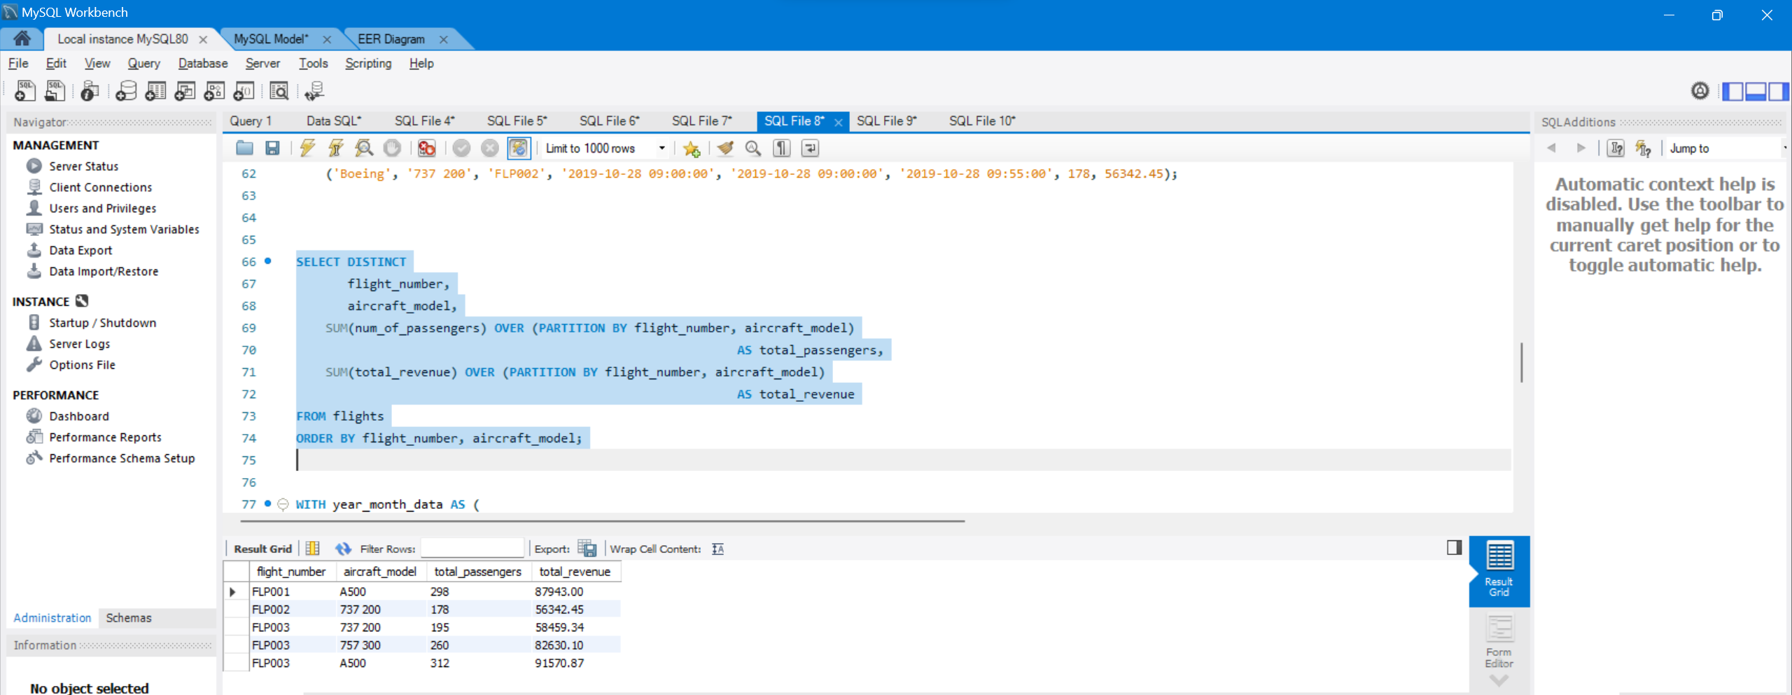 **Example 2**

In the next query, we show how the business evolves by comparing metrics from one month with those from the previous month. We create a report using window functions to show the monthly variation in passengers and revenue.

|  |
| --- |
| WITH year_month_data AS (    SELECT DISTINCT         EXTRACT(YEAR FROM scheduled_departure) AS year,         EXTRACT(MONTH FROM scheduled_departure) AS month,         SUM(number_of_passengers)                OVER (PARTITION BY EXTRACT(YEAR FROM scheduled_departure),                                    EXTRACT(MONTH FROM scheduled_departure)                     ) AS passengers     FROM  paris_london_flights    ORDER BY 1, 2  )  SELECT  year,          month,       passengers,       LAG(passengers) OVER (ORDER BY year, month) passengers_previous_month,       passengers - LAG(passengers) OVER (ORDER BY year, month) AS passengers_delta  FROM year_month_data; |

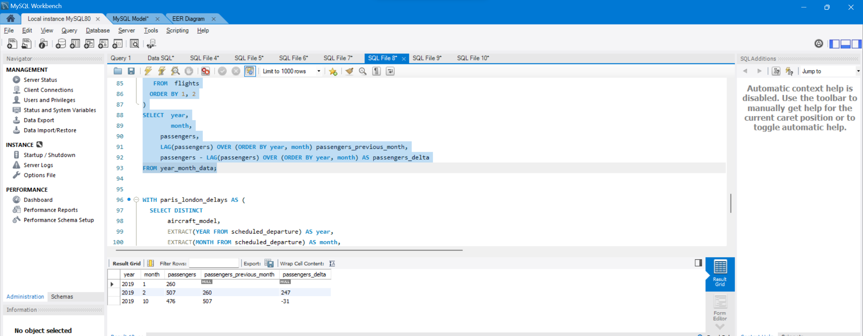**Example 3**

For our last example, let’s look at flight delays. We want to obtain different delay averages to explain the reasons behind the delays.

We use a CTE to calculate a column called month_delay with the average delay for each month and obtain the aircraft model. Then in the main query, we obtain the different averages as we see below:

|  |
| --- |
| WITH paris_london_delays AS (    SELECT DISTINCT         aircraft_model,         EXTRACT(YEAR FROM scheduled_departure) AS year,         EXTRACT(MONTH FROM scheduled_departure) AS month,         AVG(real_departure - scheduled_departure) AS month_delay     FROM  paris_london_flights     GROUP BY 1, 2, 3  )  SELECT  DISTINCT       aircraft_model,       year,       month,       month_delay AS monthly_avg_delay,       AVG(month_delay) OVER (PARTITION BY aircraft_model, year) AS year_avg_delay,       AVG(month_delay) OVER (PARTITION BY year) AS year_avg_delay_all_models,       AVG(month_delay) OVER (PARTITION BY aircraft_model, year                                 ORDER BY month                                 ROWS BETWEEN 3 PRECEDING AND CURRENT ROW                              ) AS rolling_average_last_4_months    FROM paris_london_delays  ORDER BY 1,2,3 |

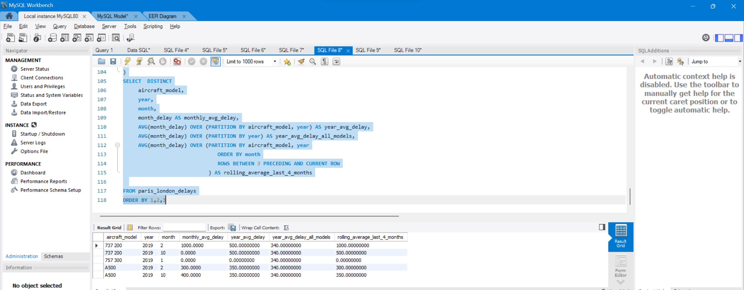

**SnowFlake Schema:**

A snowflake schema is a normalized form of a data warehouse schema in which dimension tables are further divided into sub-dimensions, creating a hierarchical structure. Unlike a star schema, the snowflake schema avoids data redundancy by storing normalized data in separate tables, enhancing data integrity. The name "snowflake" reflects the visual representation of the schema, resembling the shape of a snowflake due to its multi-level normalization.

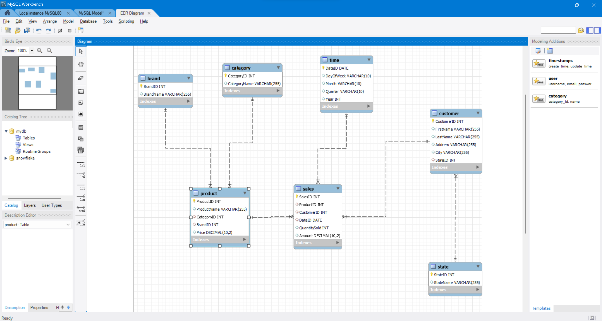

**In this example:**

* Product, Customer, and Time are dimension tables.
* Category and Brand are sub-dimensions of the Product dimension.
* State is a sub-dimension of the Customer dimension.
* The Sales table is the fact table, which contains measures such as QuantitySold and Amount, and foreign keys referencing the dimension tables.

**Star Schema:**

A star schema is a database design with a central fact table linked to dimension tables through foreign key relationships. It simplifies complex queries in business intelligence by facilitating easy navigation and aggregation. This structure enhances performance for analytical processing, making it common in data warehousing.

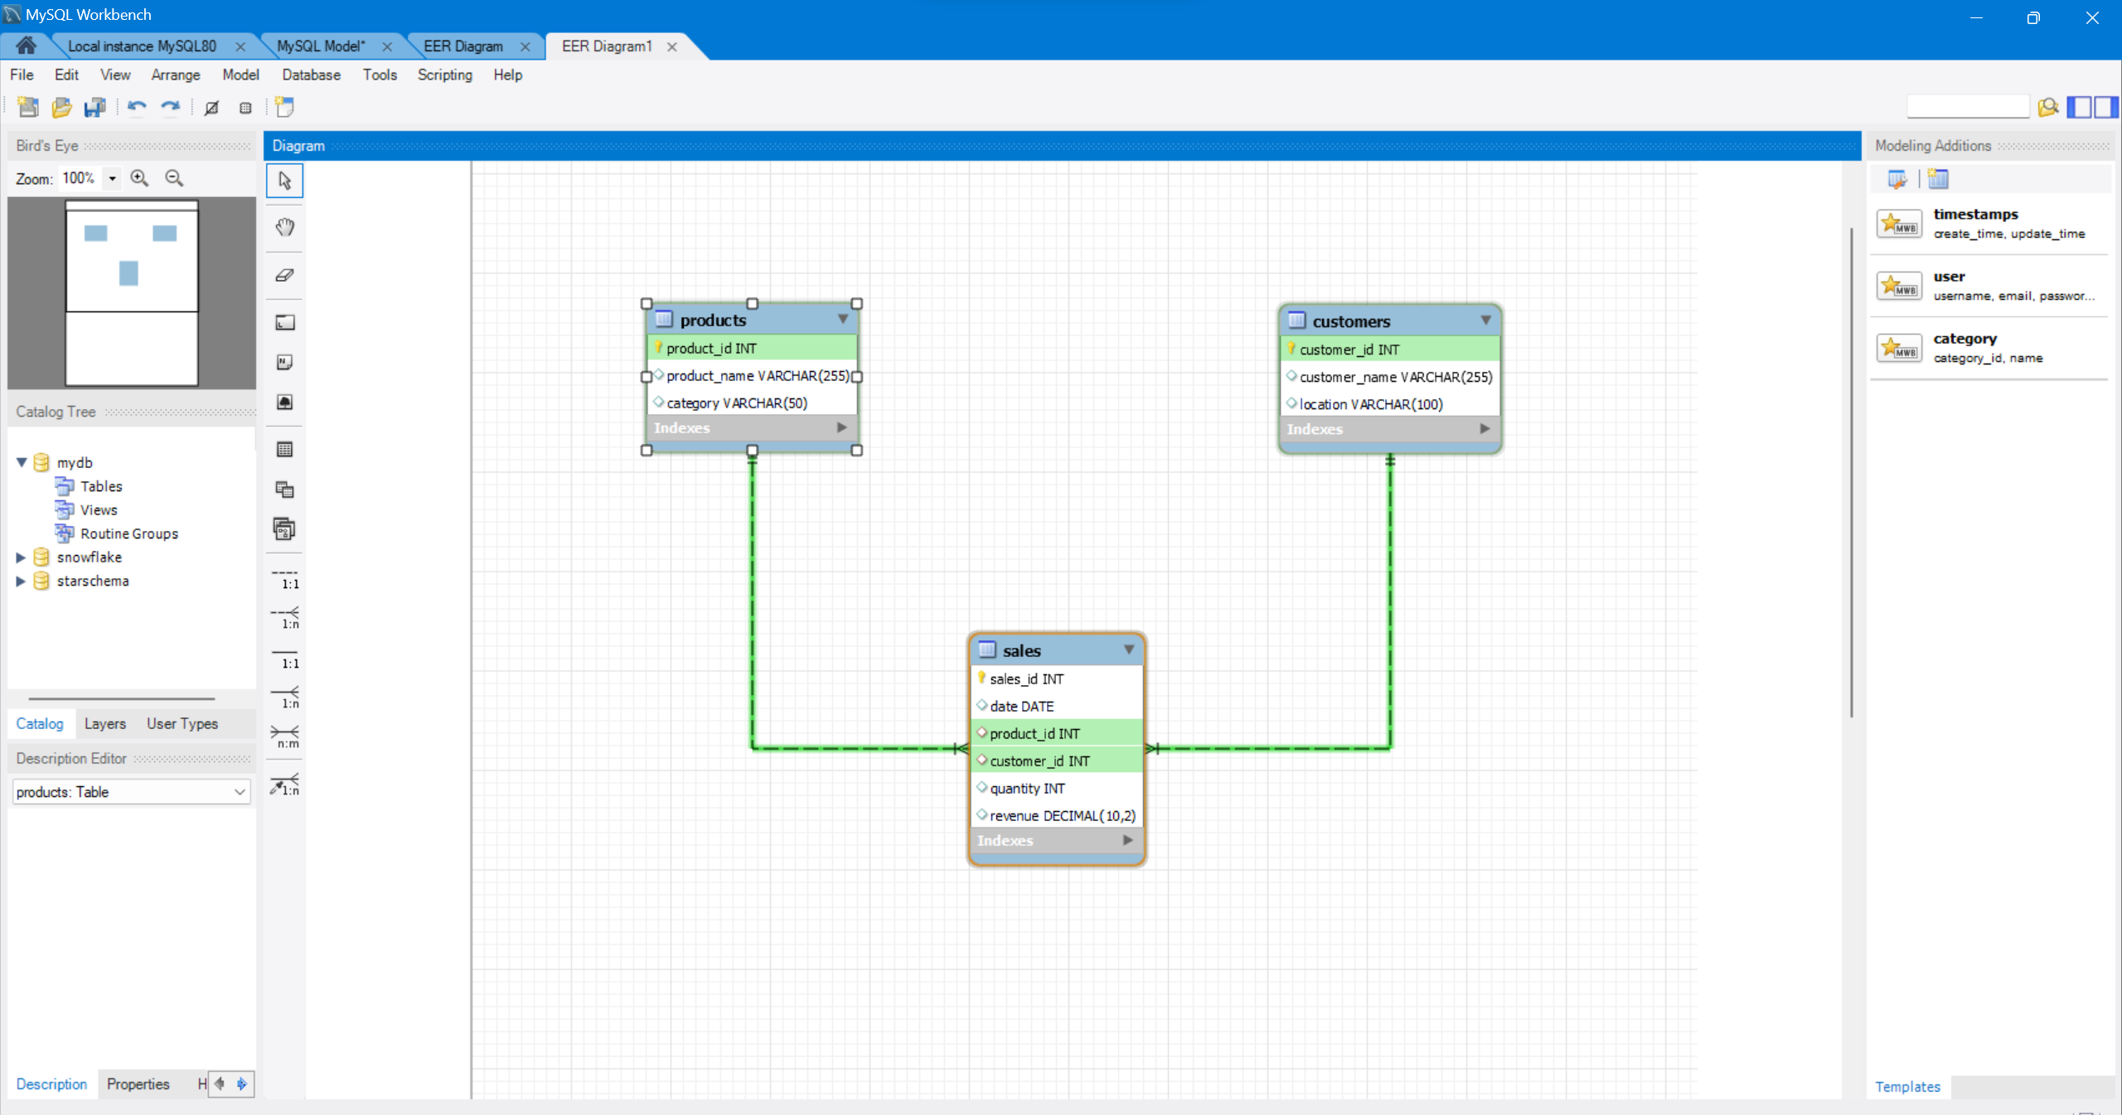

In this example, we have three tables: Sales (fact table), Products (dimension table), and Customers (dimension table). The foreign key relationships are established between the Sales table and the Products and Customers tables.

**The Stages of SQL Order of Execution**

| **Clause** | **Order** | **Description** |
| --- | --- | --- |
| **FROM** | 1 | The query begins with the FROM clause, where the database identifies the tables involved and accesses the necessary data. |
| **WHERE** | 2 | The database applies the conditions specified in the WHERE clause to filter the data retrieved from the tables in the FROM clause. |
| **GROUP BY** | 3 | If a GROUP BY clause is present, the data is grouped based on the specified columns, and aggregation functions (such as SUM(), AVG(), COUNT()) are applied to each group. |
| **HAVING** | 4 | The HAVING clause filters the aggregated data based on specified conditions. |
| **SELECT** | 5 | The SELECT clause defines the columns to be included in the final result set. |
| **ORDER BY** | 6 | If an ORDER BY clause is used, the result set is sorted according to the specified columns. |
| **LIMIT/OFFSET** | 7 | If LIMIT or OFFSET clause is present, the result set is restricted to the specified number of rows and optionally offset by a certain number of rows. |

SELECT

Name,

COUNT(*) AS TotalCount,

AVG(Age) AS AvgAge

FROM

ExampleTable

WHERE

Age IS NOT NULL

GROUP BY

Name

HAVING

COUNT(*) > 1

ORDER BY

AvgAge DESC

LIMIT 5 OFFSET 0;

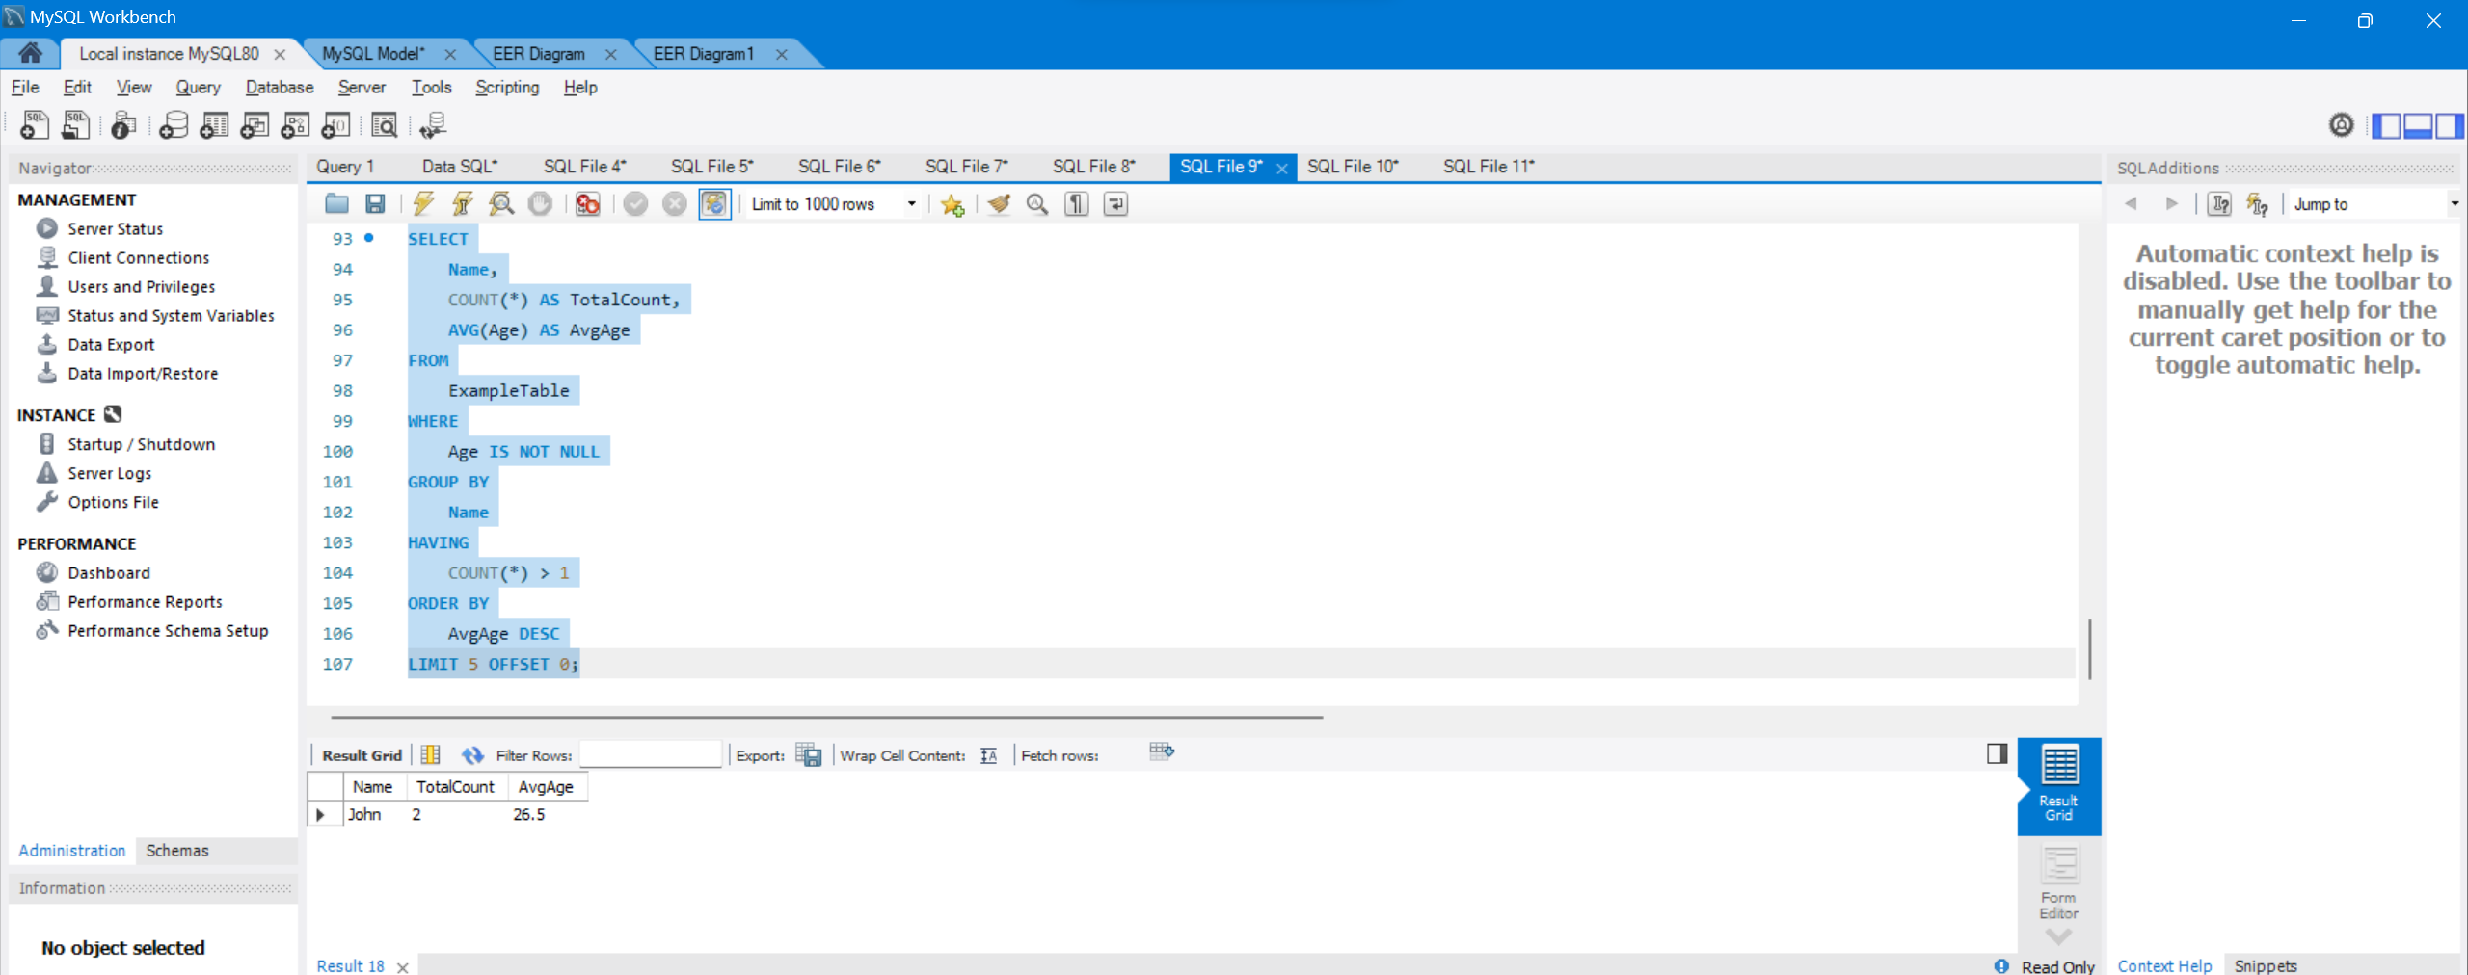

**How to calculate Subtotals in SQL Queries**

A subtotal is a figure that shows the sum of similar sets of data but it does not indicate the final total. Subtotals are mainly used in sales, finance, and accounting reports.

Pre-Requirement

In the following examples of the article, we will use the SalesList sample table and the following query helps to create this example table and it will also populate some sample data to this table.

|  |  |
| --- | --- |
| 1  2  3  4  5  6  7  8  9  10  11  12  13  14  15  16 | CREATE TABLE  SalesList  (SalesMonth NVARCHAR(20), SalesQuartes  VARCHAR(5), SalesYear  SMALLINT, SalesTotal MONEY)  GO  INSERT INTO  SalesList(SalesMonth,SalesQuartes,SalesYear,SalesTotal) VALUES (N'March','Q1',2019,60)  INSERT INTO SalesList(SalesMonth,SalesQuartes,SalesYear,SalesTotal) VALUES (N'March','Q1',2020,50)  INSERT INTO SalesList(SalesMonth,SalesQuartes,SalesYear,SalesTotal) VALUES (N'May','Q2',2019,30)  INSERT INTO SalesList(SalesMonth,SalesQuartes,SalesYear,SalesTotal) VALUES (N'July','Q3',2020,10)  INSERT INTO SalesList(SalesMonth,SalesQuartes,SalesYear,SalesTotal) VALUES (N'November','Q4',2019,120)  INSERT INTO SalesList(SalesMonth,SalesQuartes,SalesYear,SalesTotal) VALUES (N'October','Q4',2019,150)  INSERT INTO SalesList(SalesMonth,SalesQuartes,SalesYear,SalesTotal) VALUES (N'November','Q4',2019,180)  INSERT INTO SalesList(SalesMonth,SalesQuartes,SalesYear,SalesTotal) VALUES (N'November','Q4',2020,120)  INSERT INTO SalesList(SalesMonth,SalesQuartes,SalesYear,SalesTotal) VALUES (N'July','Q3',2019,160)  INSERT INTO SalesList(SalesMonth,SalesQuartes,SalesYear,SalesTotal) VALUES (N'March','Q1',2020,170)  GO  SELECT  * FROM SalesList |

Understanding ROLLUP extension

The GROUP BY statement is used to groups the rows that have the same values in a new summary row and it is the lead actor of the aggregate queries. ROLLUP, CUBE, and GROUPING SETS are extensions of the GROUP BY statement and add the extra subtotal and grand total rows to the resultset. In order to calculate a subtotal in SQL query, we can use the ROLLUP extension of the GROUP BY statement. The **ROLLUP** extension allows us to generate hierarchical subtotal rows according to its input columns and it also adds a grand total row to the result set.

**Example-1:**

|  |  |
| --- | --- |
| 1  2 | SELECT  SalesYear, SUM(SalesTotal) AS SalesTotal FROM SalesList      GROUP BY ROLLUP(SalesYear) |

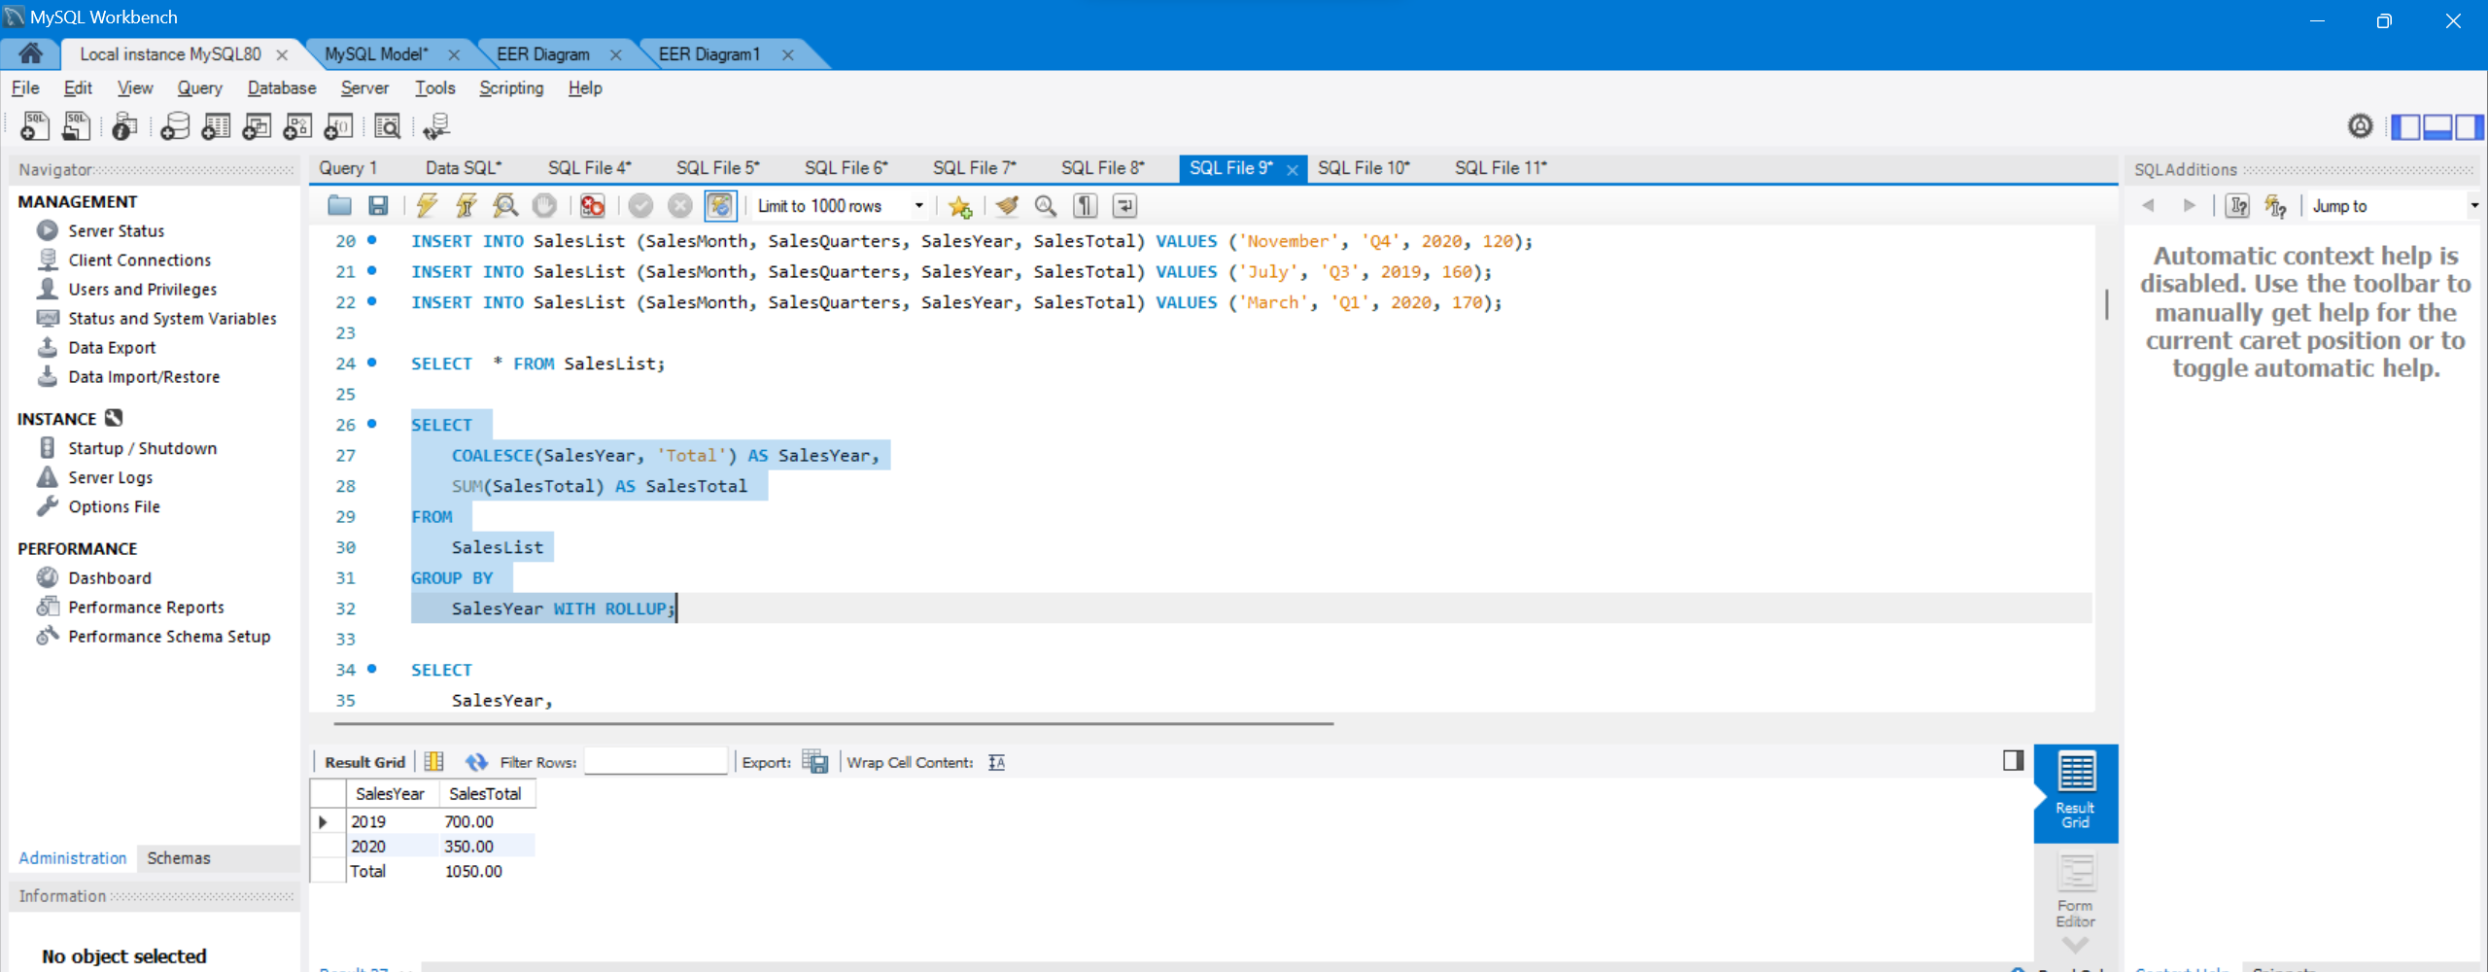

|  |  |
| --- | --- |
| 1  2 | SELECT  SalesYear,SalesQuartes, SUM(SalesTotal) AS SalesTotal      FROM SalesList GROUP BY ROLLUP(SalesYear, SalesQuartes) |

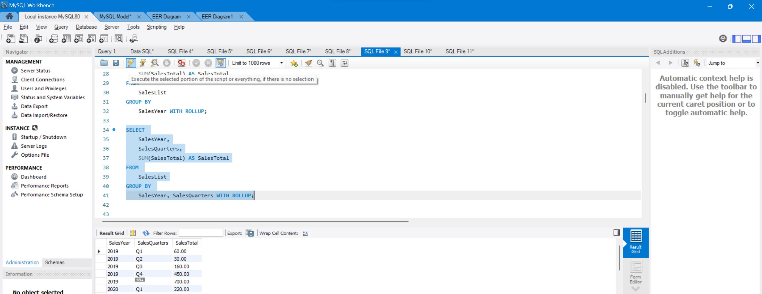

**Example-3:**

In this example, we will pass 3 columns into the ROLLUP extension and then this extension will generate subtotal rows for all hierarchies.

|  |  |
| --- | --- |
| 1  2 | SELECT  SalesYear,SalesQuartes,SalesMonth ,SUM(SalesTotal) AS SalesTotal  FROM SalesList GROUP BY ROLLUP(SalesYear, SalesQuartes, SalesMonth) |

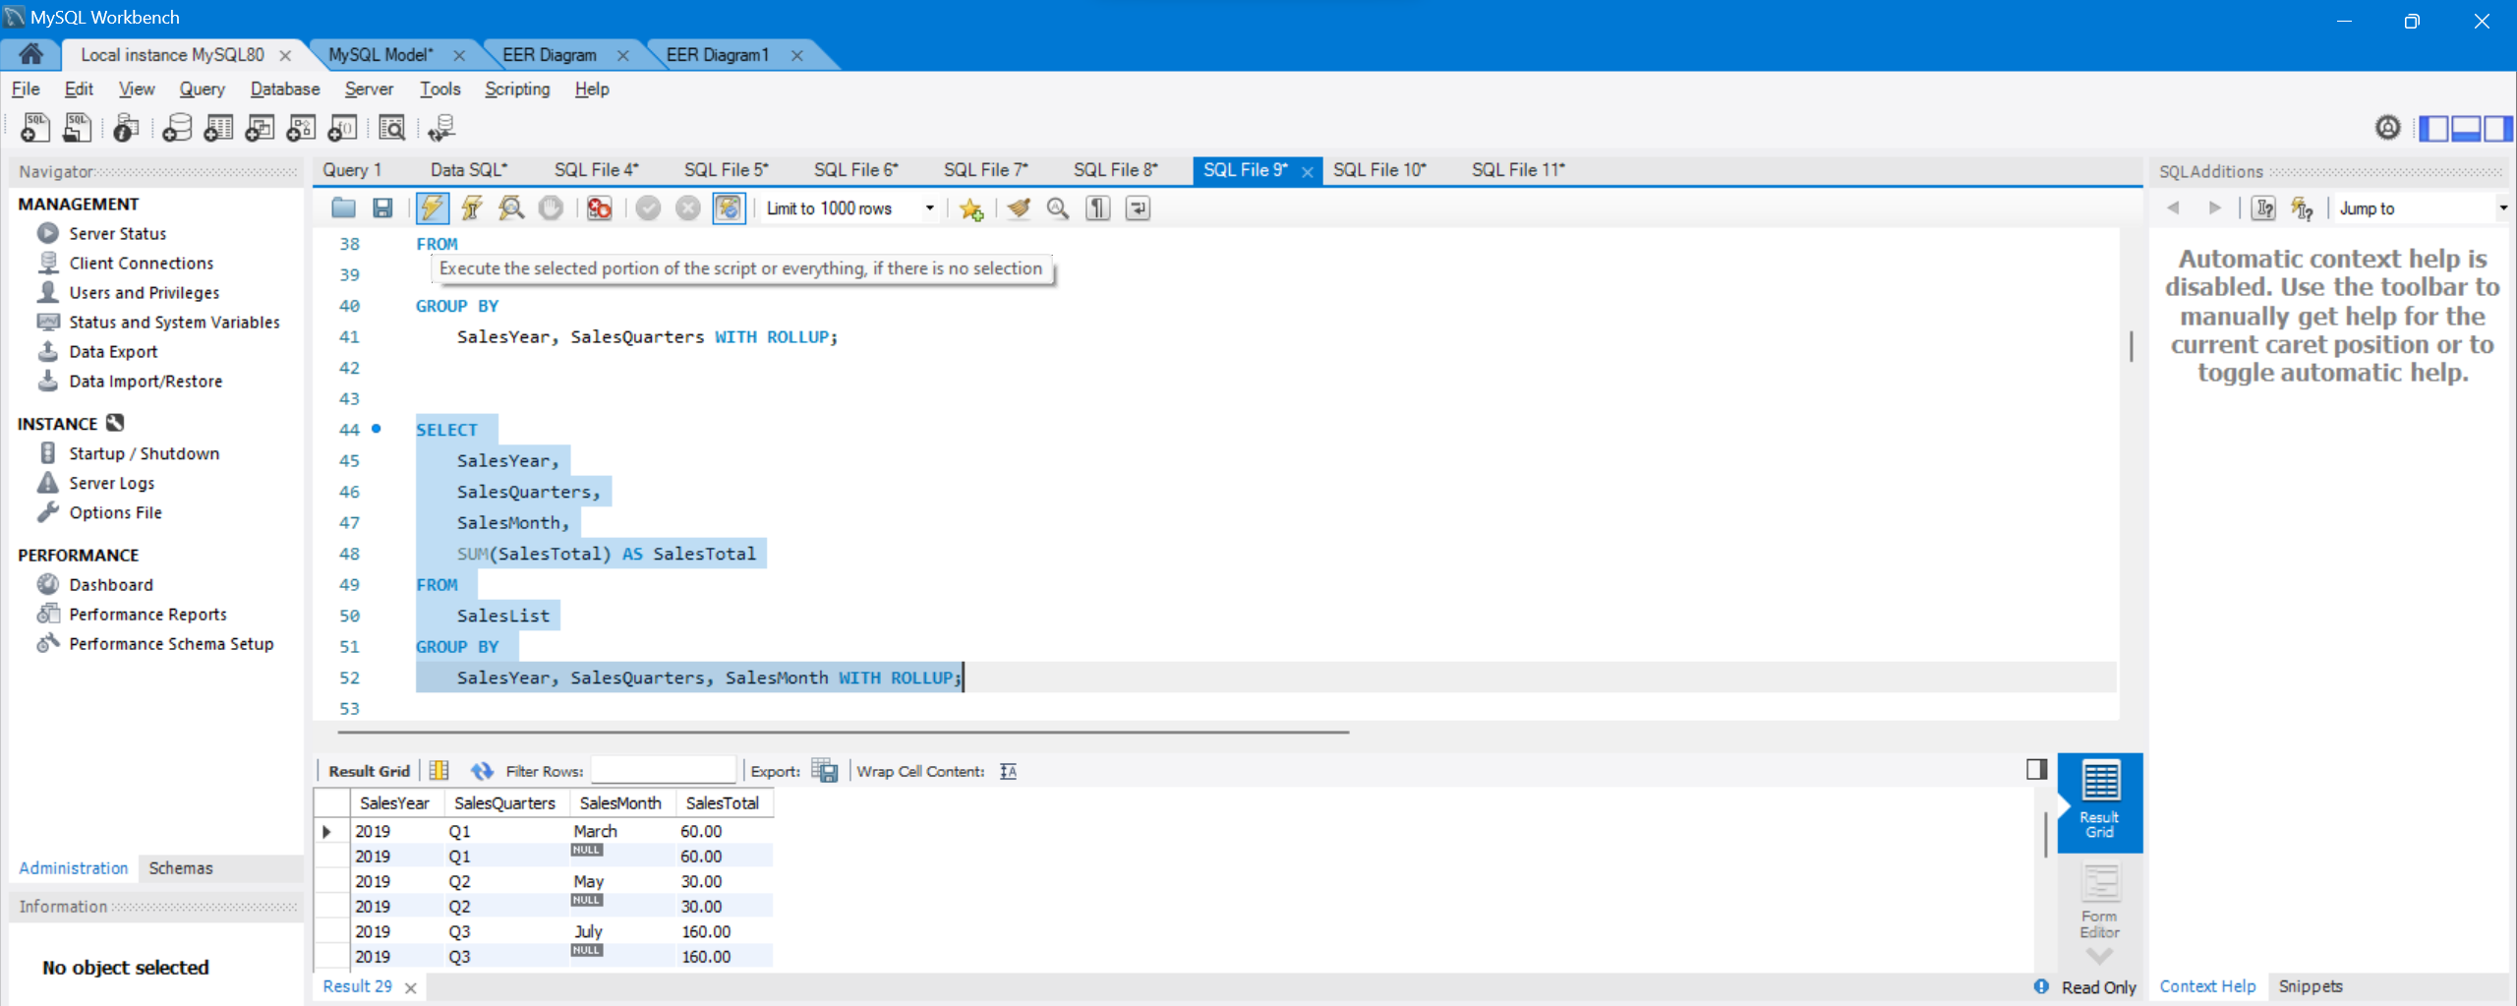

Understanding GROUPING function

The GROUPING function is used to determine whether the columns in the GROUP BY list have been aggregated. Therefore, we can use this function to identify the NULL values and replace them.

|  |  |
| --- | --- |
| 1  2  3  4  5  6  7 | SELECT SalesYear,  SalesQuartes,  SUM(SalesTotal) AS SalesTotal ,  GROUPING(SalesQuartes) AS SalesQuarterGrp,  GROUPING(SalesYear) AS SYearGrp  FROM SalesList  GROUP BY ROLLUP(SalesYear, SalesQuartes) |

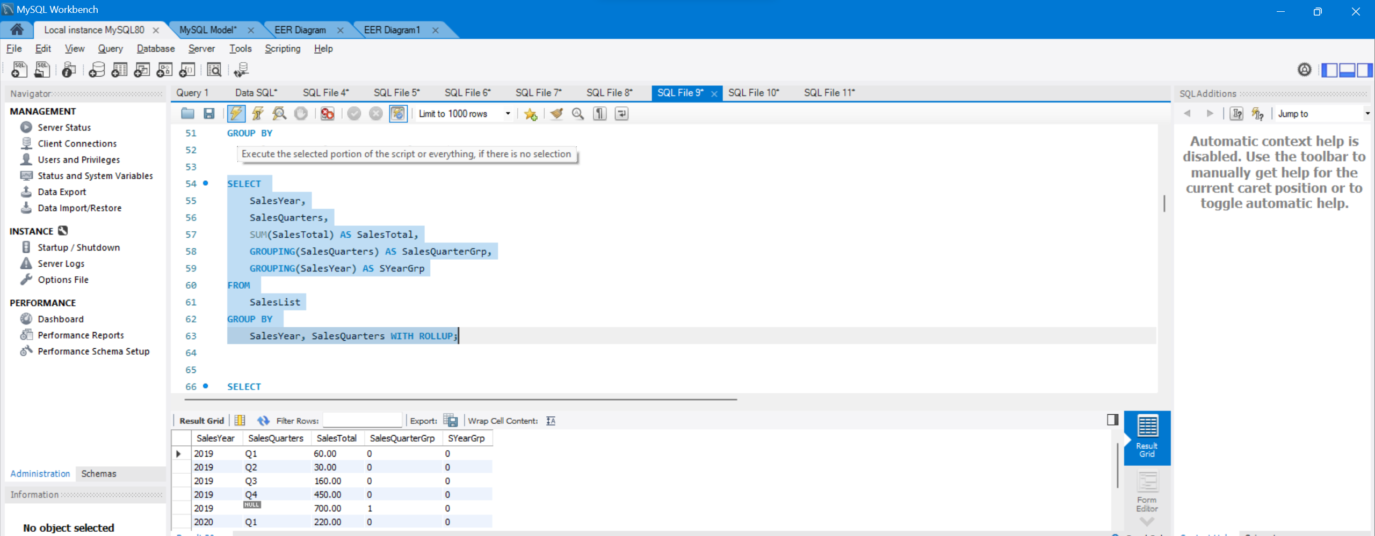

As we can see, grouped rows are determined by GROUPING functions. Now we will use the SQL CASE statement and GROUPING function together so that we will replace NULL values with more meaningful explanations.

As a result, we added a subtotal and grand total row to the result set with help of the ROLLUP extension.

Calculate subtotal in SQL query only for one column

For some cases, we may require to add a subtotal in SQL query for only one column. In this circumstance, we can use the ROW_NUMBER() and NEWID() function together to handle this issue. The reason for this combo usage is to add a unique number to each row and then we will use that numbered row for grouping.

|  |  |
| --- | --- |
| 1  2 | SELECT SalesMonth,SalesTotal ,  ROW_NUMBER() OVER(ORDER BY NEWID()) AS RowNumber FROM SalesList |

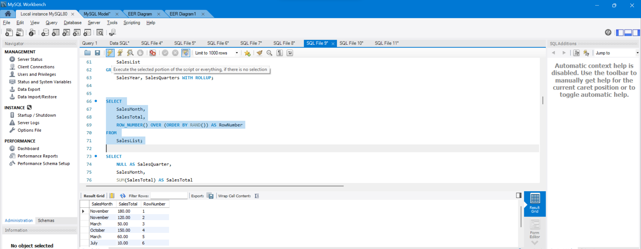

Using GROUPING SET extension as an alternative method

GROUPING SETS is another GROUP BY extension and it allows us to display multiple grouping set in one query. Such as, when we want to display monthly and quarterly sales in one result set we can use the UNION ALL statement but this would be an impractical method.

|  |  |
| --- | --- |
| 1  2  3  4  5  6  7  8  9 | SELECT NULL AS SalesQuarter, SalesMonth,  SUM(SalesTotal) AS SalesTotal  FROM  SalesList  GROUP BY SalesMonth  UNION ALL      SELECT  SalesQuartes, NULL AS SalesMonth,  SUM(SalesTotal) AS SalesTotal  FROM  SalesList  GROUP BY SalesQuartes |

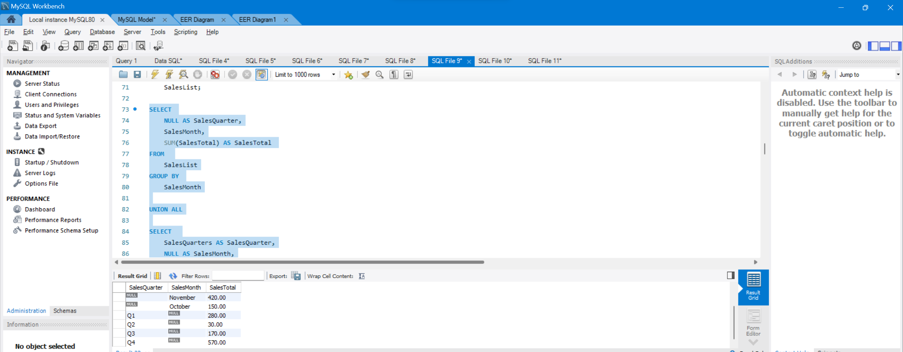

**Regex:**

SELECT *

FROM ExampleTable

WHERE Name REGEXP 'A.*';

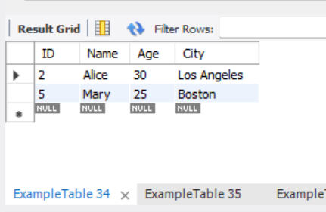

SELECT *

FROM ExampleTable

WHERE Name REGEXP 'B.+';

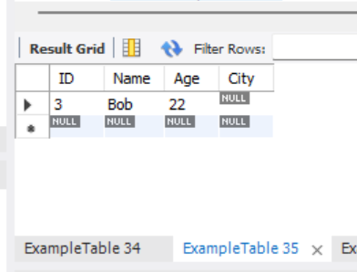

-- Select rows where the Name contains 'l' followed by any single character

SELECT *

FROM ExampleTable

WHERE Name REGEXP 'l.';

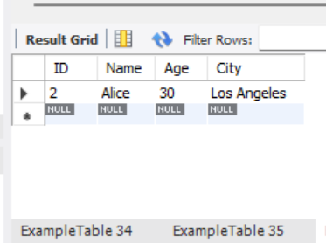

-- Select rows where the City may or may not start with 'San'

SELECT *

FROM ExampleTable

WHERE City REGEXP '^San?';

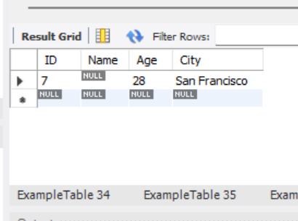

-- Select rows where the City ends with 'go'

SELECT *

FROM ExampleTable

WHERE City REGEXP 'go$';

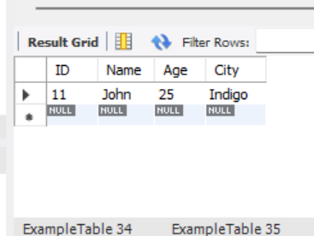

SELECT *

FROM ExampleTable

WHERE Name REGEXP '^[JA]';

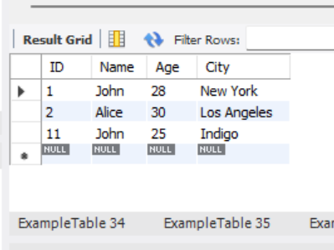

-- Select rows where the Name does not start with 'M' or 'A'

SELECT *

FROM ExampleTable

WHERE Name REGEXP '^[^MA]';

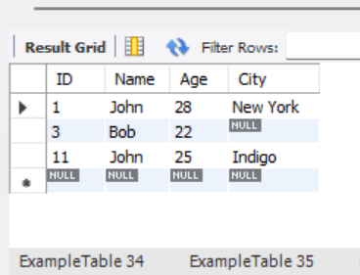

-- Select rows where the City starts with an upper case letter

SELECT *

FROM ExampleTable

WHERE City REGEXP '^[A-Z]';

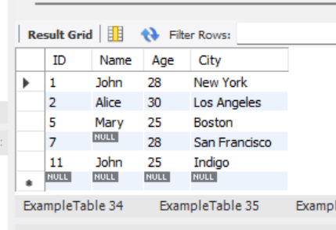

-- Select rows where the City starts with a lower case letter

SELECT *

FROM ExampleTable

WHERE City REGEXP '^[a-z]';

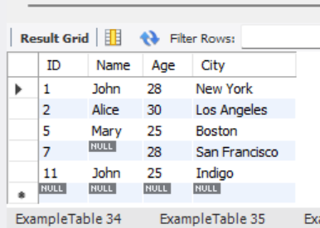

-- Select rows where the Age starts with a digit

SELECT *

FROM ExampleTable

WHERE Age REGEXP '^[0-9]';

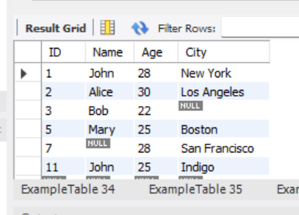

SELECT *

FROM ExampleTable

WHERE Name REGEXP '^[[:upper:]]';

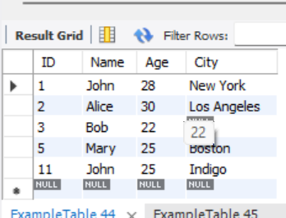

-- Select rows where the Name starts with 'J' or ends with 'y'

SELECT *

FROM ExampleTable

WHERE Name REGEXP 'J|y';

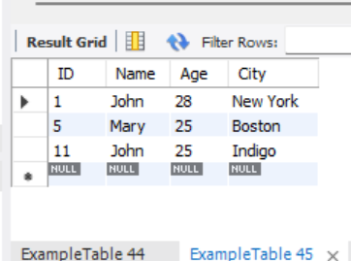

-- Select rows where the Name has exactly 3 characters

SELECT *

FROM ExampleTable

WHERE Name REGEXP '^...$';

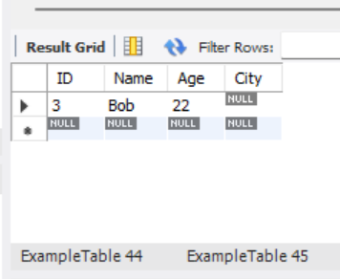

-- Select rows where the Name has 2 to 4 characters

SELECT *

FROM ExampleTable

WHERE Name REGEXP '^.{2,4}$';

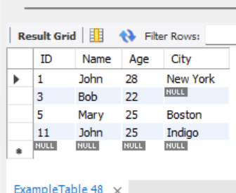

Views

A view in a database is a virtual table based on a SELECT query, providing a way to represent data without storing it. It simplifies complex queries and offers a level of abstraction over the underlying tables. Views can enhance security by restricting access to specific columns or rows.

-- Creating the ExampleTableView

CREATE VIEW ExampleTableView AS

SELECT ID, Name, Age

FROM ExampleTable

WHERE Age IS NOT NULL;

-- Querying the original ExampleTable

SELECT * FROM ExampleTable;

-- Querying the ExampleTableView

SELECT * FROM ExampleTableView;

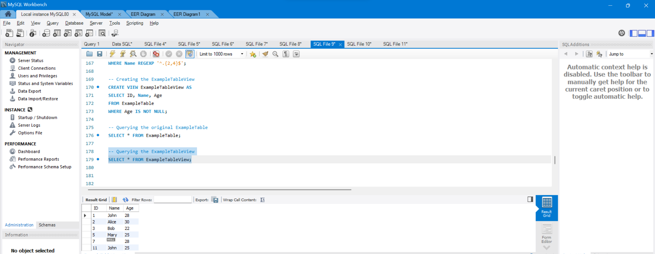

Rules and Restrictions to Group and Filter Data in SQL queries

GROUP BY:

An introduction to the GROUP BY clause and FILTER modifier.

GROUP BY enables you to use aggregate functions on groups of data returned from a query.

FILTER is a modifier used on an aggregate function to limit the values used in an aggregation. All the columns in the select statement that aren’t aggregated should be specified in a GROUP BY clause in the query.

GROUP BY

Returning to a previous section, when we were working with aggregations, we used the aggregate function AVG to find out the average deal size. If we wanted to know the average value of the deals won by each sales person from highest average to lowest, the query would look like:

SELECT

Name,

AVG(Age) AS AverageAge

FROM

ExampleTable

WHERE

Age IS NOT NULL

GROUP BY

Name

ORDER BY

AverageAge DESC;

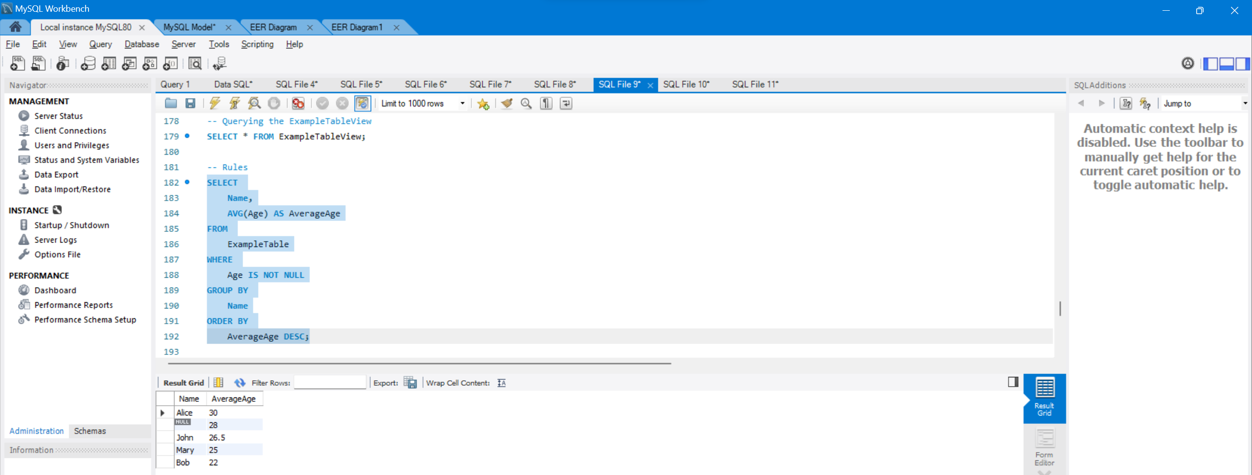

FILTER:

If you wanted to refine your query even more by running your aggregations against a limited set of the values in a column you could use the FILTER keyword. For example, if you wanted to know both the number of deals won by a sales agent and the number of those deals that had a value greater than 1000, you could use the query:

SELECT sales_agent,

COUNT(sales_pipeline.close_value) AS total,

COUNT(sales_pipeline.close_value)

FILTER(WHERE sales_pipeline.close_value > 1000) AS `over 1000`

FROM sales_pipeline

WHERE sales_pipeline.deal_stage = "Won"

GROUP BY sales_pipeline.sales_agent

